
Eco-Friendly Reversible Tote Bag

One of the first projects most new sewists tackle is a Tote Bag. It’s the perfect project for beginners and you will learn the basic steps for creating your own tote bag.
This will show you how to make a tote bag that doesn’t require any special skills. If you can sew a straight stitch on your sewing machine, you can make this bag!
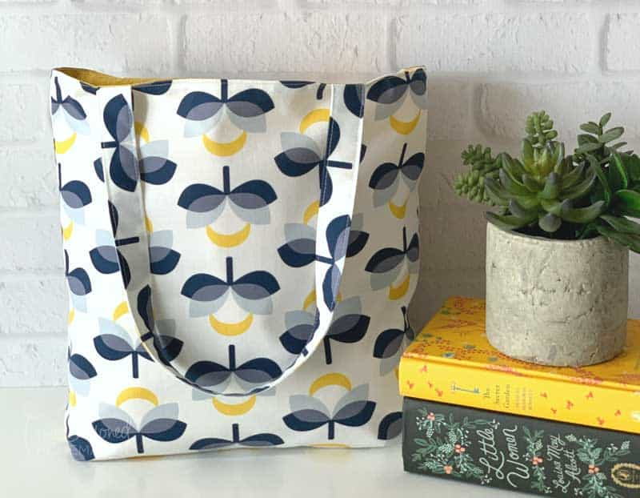

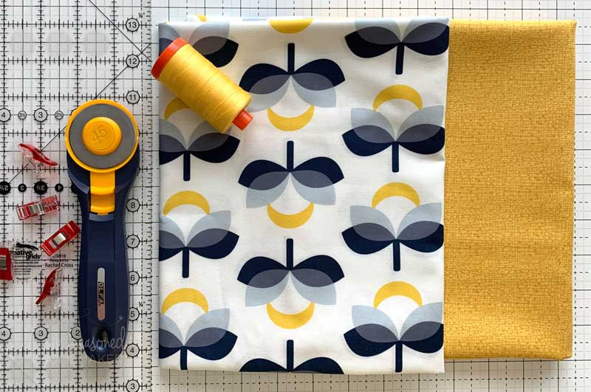

Materials
- 1/2 yd. Exterior Fabric + Handles (Exterior)
- 1/2 yd. Lining Fabric (Lining)
- Thread in coordinating color
Supplies
- Sewing Machine
- Scissors
- Water-Erasable Pen
- Wonder Clips or Straight Pins
- Rotary Cutter with sharp blade
- Acrylic Ruler
- Self-Healing Rotary Cutting Mat
- Iron & Ironing Board
- Walking Foot (optional)

Step 1: Cut Out Fabric
- From Exterior Fabric (A), cut (2) 14” x 14” for main body of bag.
- From Exterior Fabric (A), cut (2) 4″ x 22″ for bag handles.
- From Lining Fabric (B), cut (2) 14″ x 14″ for bag lining.
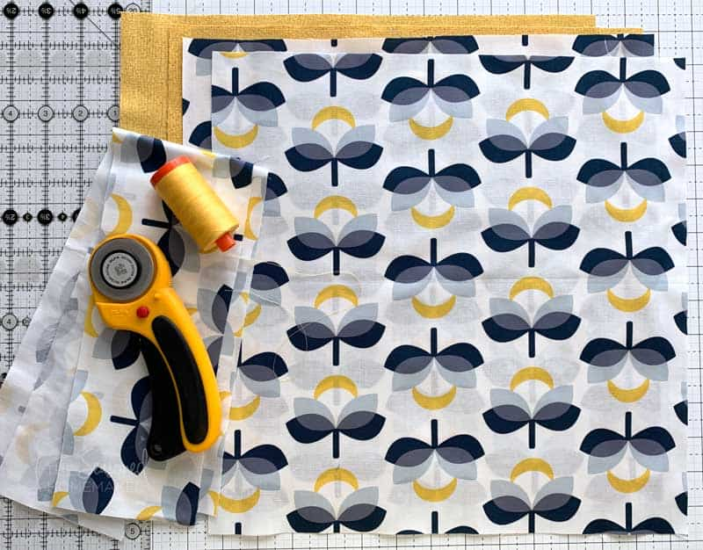

Step 2: The Bag Handles
The steps for making the bag handles are simple. And the result is a double layer of fabric which gives the handles a little more stability.
1. Prepare the bag handles by folding them lengthwise wrong sides together. Press in a crease.
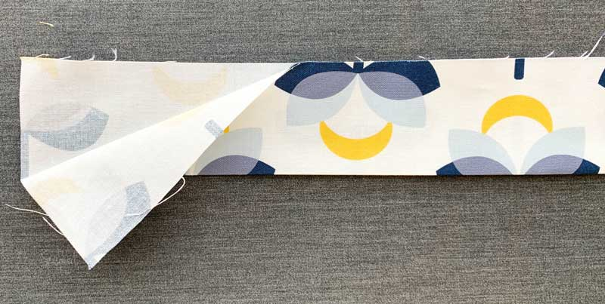
2. Fold the raw edges in on both sides in towards the crease and press again.
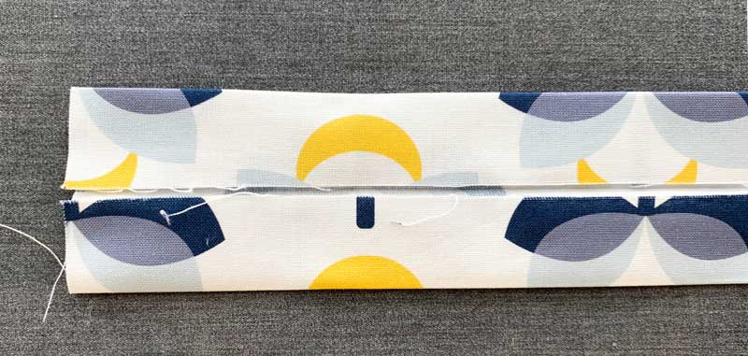
3. Fold strap in half with folded edges matching up. All raw edges should be facing inside the handle.
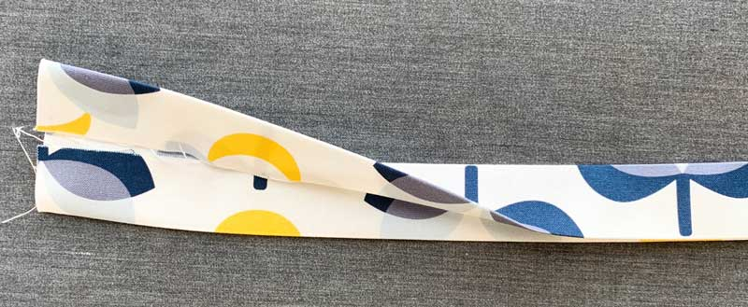
4. Clip or pin to hold.
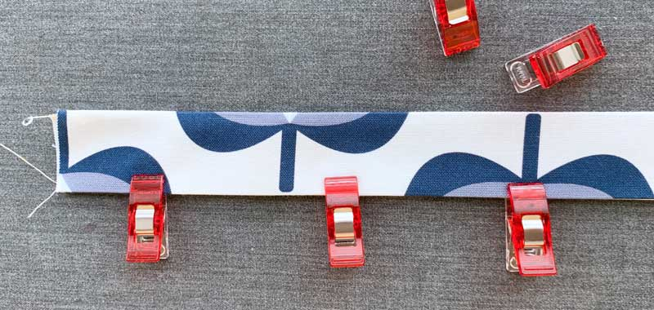
5. Using a 3-4mm stitch length, top stitch 1/8″ down both sides of bag handle. Pro Tip: If you have an Edge Stitch Foot this is the perfect place to use it!
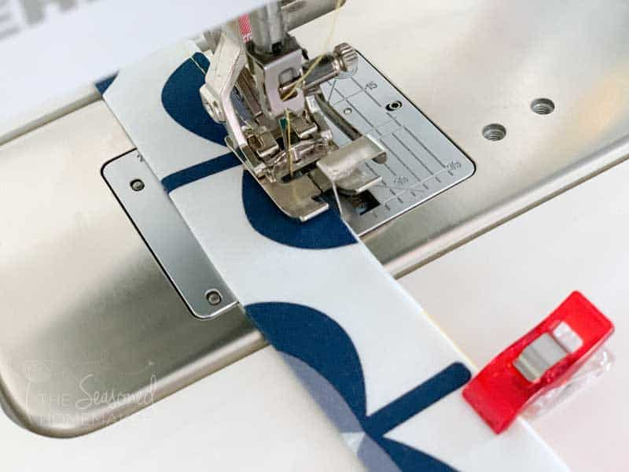
6. Repeat for second handle.

Step 3: Making the Body of the Bag
1. With right sides together, stitch the side seams and bottom of Exterior Fabric, leaving the top open. Use a 1/4” seam allowance. Note: Be sure to change your stitch length back to 2.5mm.
2. With right sides together, stitch the side seams and bottom of Lining Fabric, leaving the top open. Use a 1/4” seam allowance.
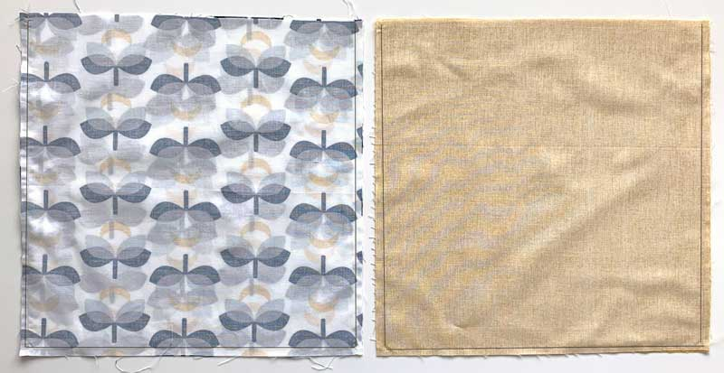

Step 4: Making a Pleat in the Bag
1. In order for the bag to have a flat bottom you will need to create a pleat. To do this, fold the bottom corner of your bag so it creates a triangle in the corner. Matching up the side seam and bottom seam will make this line up perfectly.
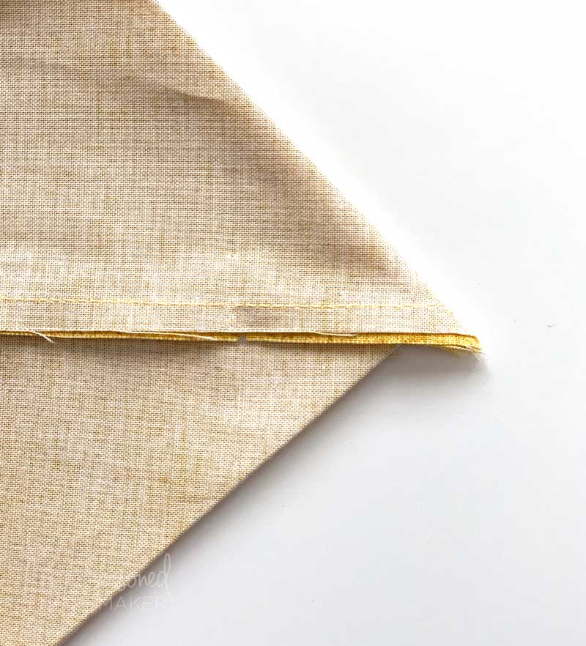
2. Pin the corner; and with your water erasable pen, make a mark 1.5” away from the corner.
3. Draw a stitching line and then stitch across to create a pleat.
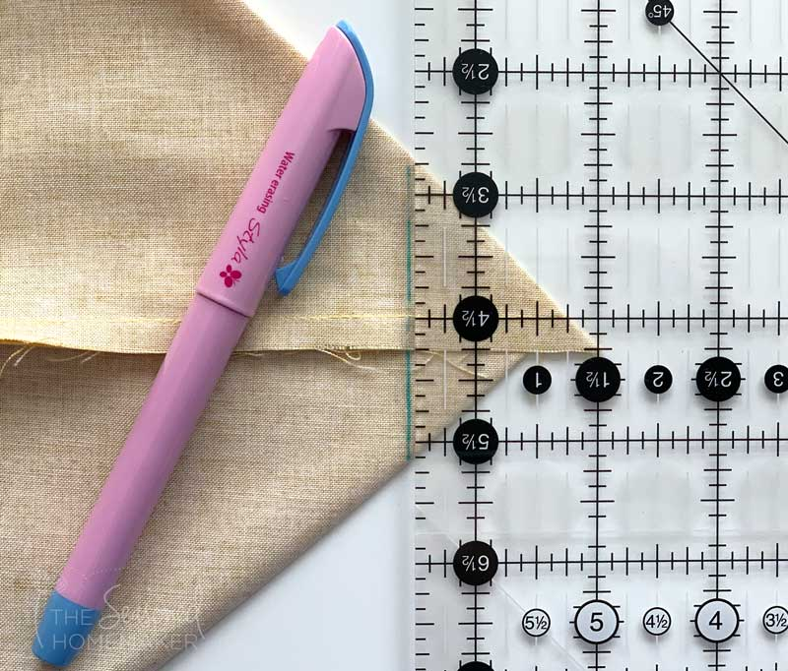
4. Clip away the triangle, leaving a 1/4” seam allowance. Be sure to remove the markings.
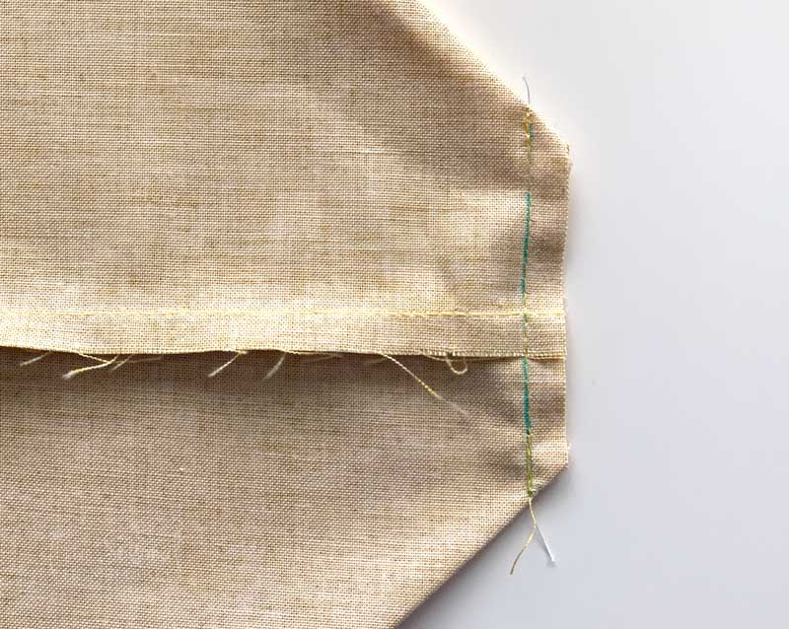
5. Repeat all corners of the Exterior and Lining of bag.

Step 5: Putting it all Together
1. Insert the Lining Fabric inside the Exterior Fabric with right sides together. Line up side seams.
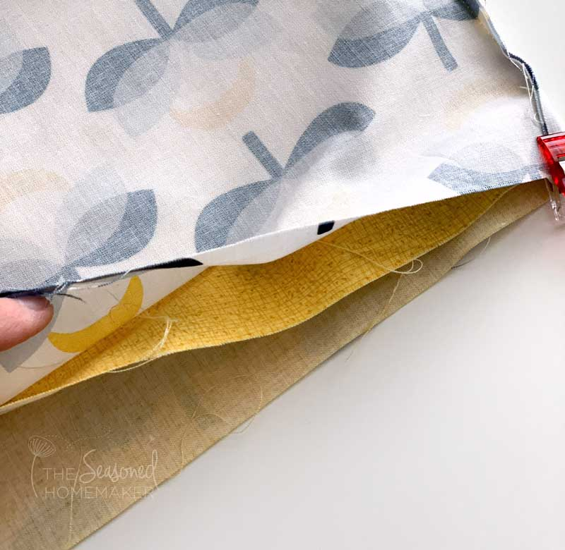
2. Insert one of the bag handles between the Exterior Fabric and Lining Fabric about 3” from the side seams (like a sandwich). Be sure your handles are straight and do not twist.
The raw edges of the bag handles should be placed side by side, approximately 5” apart.
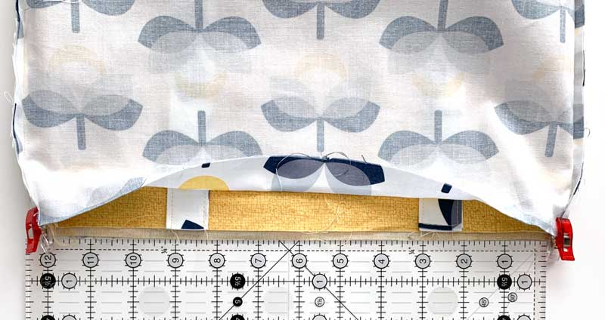
3. Pin in place and repeat on opposite side of bag. BE SURE TO LEAVE A 3” OPENING FOR TURNING YOUR BAG.
4. Using a 1/4” seam allowance, stitch around the top edge of your bag.
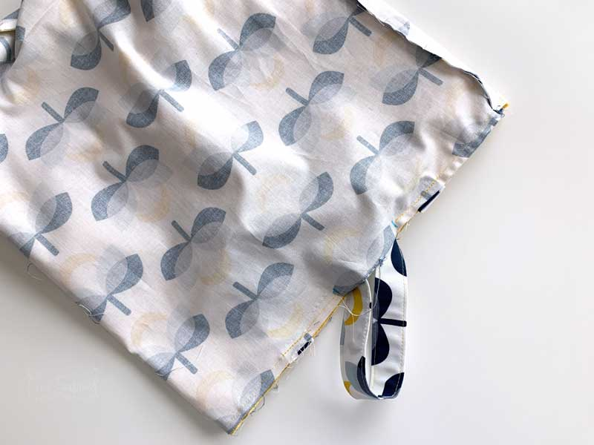

Step 6: Finishing Touches
1. Turn your bag right side out and carefully press the top seam.
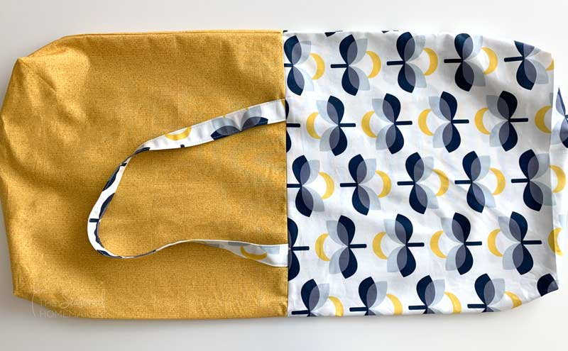
2. Push the lining fabric into the bag and press the top edge.
3. Top stitch around the entire top of the bag using a 1/8” seam. Pro Tip: This is the perfect place to use an Edge Stitch Foot!
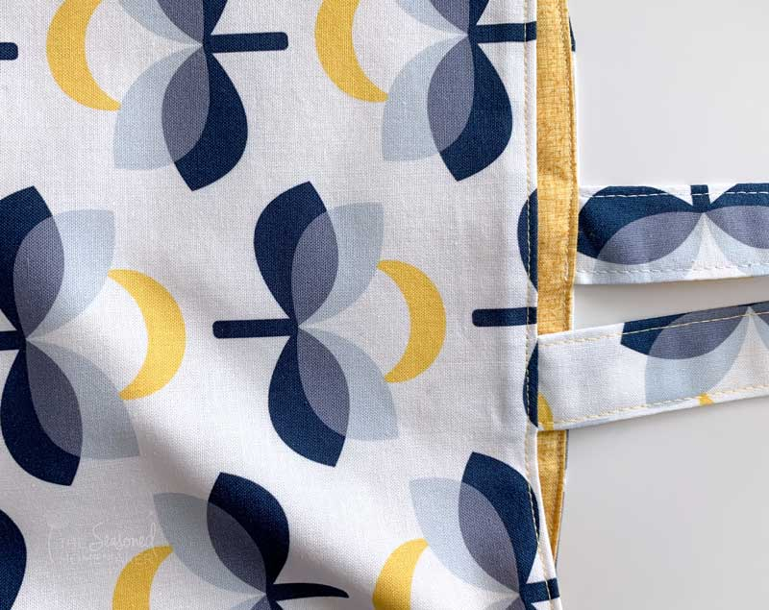

Other ideas for this bag
Now think of all the ways you can embellish your next bag. For more experienced sewists, maybe add a pocket on the inside or make a two tone bag. Or applique a monogram or favorite design.
You could make the bag firmer by adding Fusible Fleece. It’s also possible to scale the bag up – 1″ at a time until you get the perfect size!
With this bag, the possibilities are endless. You can also use a commercial pattern if you prefer.

